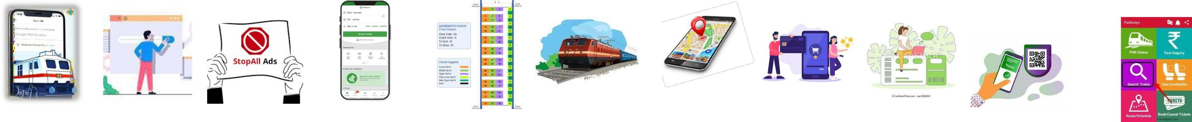PROJECT TITLE: SMART SOLUTIONS FOR RAILWAYS PROJECT DESIGN PHASE-II: CUSTOMER JOURNEY MAP TEAM ID:PNT2022TMID41962



STAGES OF JOURNEY

ACTIVITES

FEELINGS

VERY HAPPY

OVERALL SATISFIED

NOT SATISFIED

EXPERIENCES

CUSTOMER

EXPECATIONS

|  |  |  |  |  |  |  |  |  |  |
| --- | --- | --- | --- | --- | --- | --- | --- | --- | --- |
| MOTIVATION | SEARCH FOR WEBSITE | | INSIDE THE SITE | SELECT TRAIN AND PASSENGER DETAILS | | | PAYMENT | TICKETS | JOURNEY |
| Wants to book | Search online | Neglect the | Fill the from, | Check seat | Select | Add passengers | Proceed to pay Contact online | e-tickets with | “MY BOOKINGS” for QR |
| a train ticket | ticket | adds if any. | destination, date | availability and | appropriate train | and fill the details | service for help | QR-Code will be | Code access. |
| remotely. | booking on |  | and time of travel. | train details. | among the |  |  | send to the | PNR Status for accessing |
|  | search |  | Proceed with |  | availability |  |  | registered e-mail | updates regarding tickets. |
|  | engine. |  | search trains. |  |  |  |  | ID | GPS tracking for accessing |
|  |  |  |  |  |  |  |  |  | live location. |

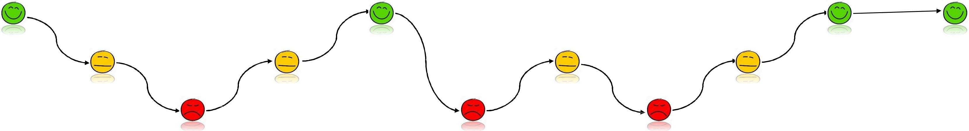

|  |  |  |  |  |  |  |  |  |  |  |
| --- | --- | --- | --- | --- | --- | --- | --- | --- | --- | --- |
| Exited to have a | Surprised to see | Annoyed to | Satisfying | Amazed to find | Confused to | Hectic process | Frustrated to | Satisfied with | Delighted to | Pleasant journey |
| better | many websites | choose due to | availability of | wide range of | select the | due to | find only | online payments | have digitalized | experience with lots of |
| commuting | confusing about | unwanted adds | stations | train availability | appropriate trains | unnecessary data | restricted | but had some | tickets | commuting facilities |
| experience | how to choose | interrupting |  | of passengers |  | entry | payment | server delay |  |  |
|  |  | while booking |  |  |  |  | options |  |  |  |
| Effective remote | More user | Allow to hide | Clear and | To view | Display trains | Avoid collecting | More payment | Faster website | To experience | Safe and secured travel |
| booking | friendly search | necessary adds | innovative website | categorized seat | based on ratings | unnecessary data | choices | speed | digitalized ticket | without any inconvenience. |
|  | engines |  | designs | availability |  |  |  |  | booking |  |